The Owl’s News

Look Whooo’s Having Fun in Pre-K

February 1, 2017

**Classroom Information**

On Friday, we will be having a show and tell time if your child wants to bring something that starts with the letter L or is mail/post office related. I am currently working on our mid-year assessments and will be sending a progress report home next week. School will be in session on Friday in order to make up the snow day we had on January 9th.

**Literacy**

This week our theme is mail/post office. We are working on writing our names, and we are practicing writing letters to our friends. We are also learning about the letter W.

**Science/Art**

This week we are completing various activities related to our post office theme.





**Next Week**

Our theme for next week folk tales/fairy tales. We will be reading several different folk tales and fairy tales. We will be completing several science, art, and literacy activities to go along with the stories. We will also be learning about the letter T.

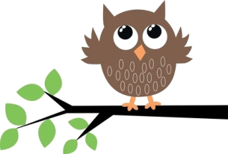

**Math**

This week we are working on shapes, counting, colors, and sorting.

Thank You!

Ms. Nieuwkoop